Double up statistics
Software Requirements Specification
Version 1.0

Table of contents
Glossary 3
Overall description 4
Main functionality 5
Double Up Statistics Report 5
Как происходит подсчет использований Double Up 5
Double Up Report Info 9
Сценарий использования 10
Double Up in Player Game Info 12
Сценарий использования 12
Notifications about Double Up activity 14
Сценарий использования 14

Glossary
Casino Manager (CM) – BSG back-office system, through which promotional campaigns can be created and the necessary reports on ongoing and completed promotions are available.
Double up – game mechanic in which the player puts either the entire amount or half from the winnings of the last round, then chooses one of the two buttons - heads or tails – and then either takes the winnings in the form of double bet or loses them.
Double up notifications – a message to the licensee that a particular player has used (and won from) the Double Up feature several times in one gaming session.
Player Game Info – report in the CM, which displays information about the game sessions of a particular player.
Reports & Statistics – section in CM with reports of various statistics about financial matters, game sessions, bonuses etc.
Sort options - a block of fields in which the user specifies the criteria for selecting data for the report.

Overall description
Double up statistics – block of new reports and notifications aimed at counting the statistics on players' usage of the "Double up" function in games (slot and table games). Basically, such report is made either for all users for a certain period, or for one user.
The calculation of the function usage will be made only in case if the bet in «Double Up» mode will lead to the winning. In addition to that, the report also counts the amounts of winnings and bets of game sessions. More details are described in the section "Double Up Statistics Report".
If a player uses the Double up function more than the specific number of times in one game session, a notification will be sent to the licensee with information about the player and his game session. The number of times will be determined in the licensee's bank settings and will be changed at his request by the configurators. Such functionality allows to keep track of all changes in statistics and to react to them promptly.

Main functionality
The functionality of double up counting consists of sections:
- Double Up Statistics Report
- Double Up Report Info
- Double Up in Player Game Info
- Notifications about Double up activity

Double Up Statistics Report
This report located in the section "Reports & Statistics" and is a table with a list of data of gaming sessions of users, which used the function Double up, as well as their bets and winnings on this function.

How Double Up uses are calculated
- Player starts any game, that supports Double Up function and uses it during the game session.
- The system checks the results of each Double Up round
  - If this round ends up with a «Player Win» situation (Round Payout>0), the system increases the value of the variable, allocated for calculating the number of Double up uses by 1.
  - If this round ends up with a «Player Lost» situation, «double up usage» variable will not change.
- According to the calculation of the winning double up rounds, the system calculates their sum of bets and the sum of winnings.
- The session with winning Double Up rounds is recorded in Double Up Statistics Report and displayed in Player Game Info when "Player Mode" = "Double Up" is selected.

The user in CM needs a set of tools to refine the data sampling for the report. For this purpose, the system provides a set of parameters, which are described in Table 1.
Table 1. Sorting parameters
№ | Title | Description | Type | Mandatory
Information about casino (or a path to users’ location)
1. | Cluster | A list of cluster names on which the subcasinos are located. | Select | Yes
2. | Subcasino | A list of subcasino’s names, that are located on the cluster. User can choose from one to all subcasinos. | Multi-select | Yes
3. | Bank | A list of banks’ names, that are located on the subcasino. User can choose from one to all banks. |  | Yes
Session Info
4. | Start Date and Time | The starting date and time of the period to view the double up usage sessions.  Timezone should be based on user Casino Manager settings. | Date/Time | Yes
5. | End Date and Time | The date and time of the end of the search period for the double up usage sessions.  Timezone should be based on user Casino Manager settings. | Date/Time | Yes
Player Info
6 | Account | List with three values:  - All  - Test  - Live  Helps to divide all test players’ data from live ones. | Select | No  (All by default)
7 | Language | Filter setting to sort out players with specific language | Select | No  (All by default)
Game Info
8 | Platform | List of values:  - All  - Flash  - Win32  - Air  - Mobile  - Android  - iOS  - Windows Phone  - Vault  Describes a platform from which player started a game. | select | No  (All by default)
9 | View through game sessions | A check box to view sorting by game sessions or by game types.  If empty – system shows a report sorted by game types (slot, table, etc.)  If filled(checked) – system shows a report, in which each game session views separately. | checkbox | No

Columns and rows of the report and their descriptions are presented in Table №2.
Table №2. Double Up Statistics Report fields
№ | Title | Description | Type
1 | ExtID | External user ID. Transferred to the system from the licensee's external server. Clicking this field redirects the user to the Player Summary Info report page | link
2 | Start time | Starting time of the session | Date/time
3 | End time | Ending time of the session | Date/time
4 | Game Name | Name of the game the user played in this game session. | Text
5 | Double Up Rounds Count | The number of rounds of the double up function in a particular user session. Increases by 1 each time the user's bet in double up mode wins. | Integer
6 | Income | Sum of bets in Double up mode, which led to a win situation. | float
7 | Payout | Sum of wins in Double Up mode | Float
8 | Game Session ID | A link to the player's game session. Opens the VBA window with the session record. | link
Row with total values contains
9 | Total of double ups | Total number of uses of double up function for all players in the table | Integer
10 | Total income | Total sum of all bets | Float
11 | Total payout | Total sum of all winnings | Float
An example of a report page is shown in Figure 1.
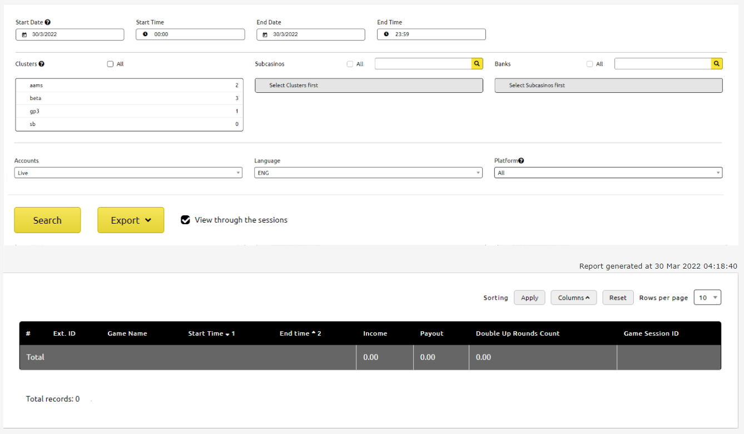
Figure 1. Layout of Double Up Statistics Report
Once the user has defined all the report parameters, he can use the functions:
- Export (XLSX/CSV) - function for exporting table data
- View detailed report by user - called by clicking on ExtID. Opens Summary Info of a user.
- View detailed report by session - called by clicking on Game Session ID and opens VBA window with a record of all actions inside the game session.

Double Up Report Info
This report is inside the Summary Info of the player and represents the statistics for all game sessions, when the player used the "Double up" function and the bet in it won.

Use Case Example
- The CM user clicks on the ExtID field in the «Double Up Statistics» report.
- The system redirects the user to the Summary Info of the player.
- The CM user selects «View» – «View Double Up Report Info».
- The system shows all the parameters and the Double Up Report Info table.
- User sets the required parameters for the report.
- The system displays the table of game sessions according to the criteria specified by the user.
This report stores the parameters (fields), which are described in Table 2, but by the game sessions of a particular user. All restrictions and dependencies were taken from there. Table №3 contains only their names and brief descriptions.
Table №3. Double Up Report Info fields
№ | Title | Description
1 | Start time | Starting time of the session
2 | End time | Ending time of the session
3 | Game Name | Name of the game the user played in this game session.
4 | № of double ups | The number of rounds of the double up function in a particular user session. Increases by 1 each time the user's bet in double up mode wins.
5 | Income | Sum of bets in Double up mode, which led to a win situation.
6 | Payout | Sum of wins in Double Up mode
7 | Game Session ID | A link to the player's game session. Opens the VBA window with the session record.
Row with total values contains
8 | Total of double ups | Total number of uses of double up function for all players in the table
9 | Total income | Total sum of all bets
10 | Total payout | Total sum of all winnings
The user in CM needs a set of tools to refine the data sampling for the report. For this purpose, the system provides a set of sorting parameters, which are described in Table 4. These parameters are similar to Double Up Statistics Report, so all the restrictions and dependencies were taken from there.
An example of a report page is shown in Figure 2.
Table №4. Double Up Report Info sorting parameters
№ | Title | Description
1. | View through game sessions | A check box to view sorting by game sessions or by game types.  If empty – system shows a report sorted by game types (slot, table, etc.)  If filled(checked) – system shows a report, in which each game session views separately.
2. | Start date and time | The starting date and time of the period to view the double up usage sessions.  Timezone should be based on user Casino Manager settings.
3. | End date and time | The date and time of the end of the search period for the double up usage sessions.  Timezone should be based on user Casino Manager settings.
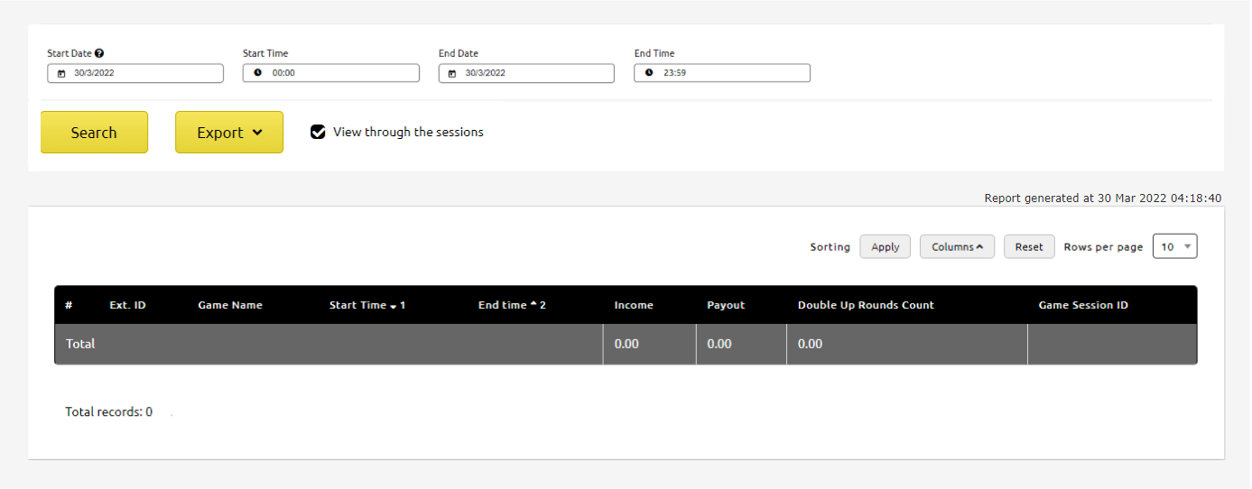
Figure 2. Double Up Report Info layout.
Once the user has defined all the report parameters, he can use the functions:
- Export (XLSX/CSV) - function for exporting table data
- View detailed report by session - called by clicking on Game Session ID and opens VBA window with a record of all actions inside the game session.

Double Up in Player Game Info
This functionality complements the Player Game Info report and displays all game sessions in which Double Up functionality was used using the Player Mode option.

Use Case Example
- The CM user selects the ExtID of the player in the Double Up Statistics Report
- The system redirects the user to Summary Info of the selected player
- User selects "View" - "View Game Info".
- The system displays the Player Game Info report its parameters
- User selects the necessary parameters and selects Player mode = "Double Up".
- The system displays in the report all the game sessions, in which in principle the Double up function was used.
In other words, the view of a particular user's session, in which the Double up function was used, will be displayed as a Player Game Info table with the parameters:
- Game name
- Start time
- End Time
- Income
- Payout
- $ Gain/Loss
- Jackpot wins
- Ext UNJ Win
- Jackpot Contributions
- UNJ Contributions (EUR)
- Rounds Count
- Negative Bet
- Start Balance
- End Balance
- Game Session ID
An example of the final output is shown in Figure 3.
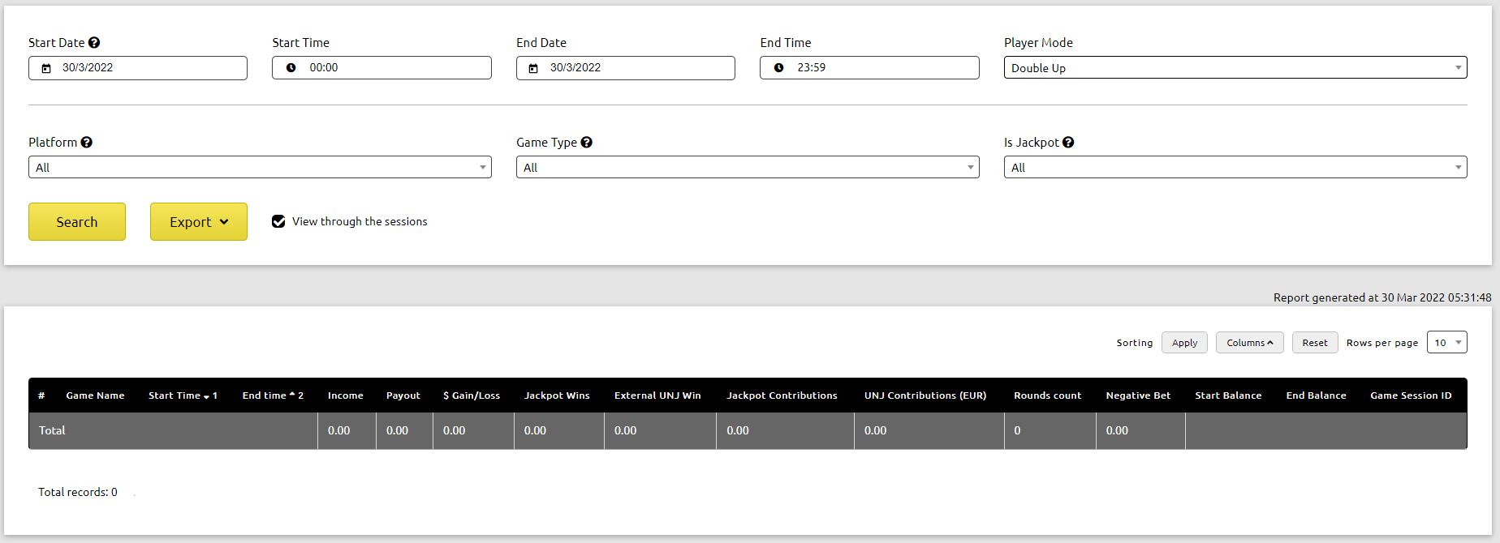
Figure 3. Player Game Info report layout with Double up Player Mode.

Notifications about Double Up activity
This feature is designed to notify the licensee in case of exceeding a certain number of Double Up feature usage for one gaming session. All notifications will be sent to the licensee's email provided when configuring the bank.
The number of uses is determined by the parameter during the configuration of the bank and can be changed by the configurators upon the licensee's request.

Use Case Example
- The player starts the game and uses the Double Up function during the game session.
- The system records the results of each round, checks if the user won in Double Up round. If yes, it increases the variable allocated for it by one.
- The player closes the game window.
- The system ends the game session and checks how many times Double Up was used.
  - If the function has been used more or as many times as the number in the bank configuration parameter, the system initiates sending a message to the licensee.
- The system generates a letter with the text: "Player [EXT_ID] used a double-up in session [GAMESESSION_ID] [N] times", which specifies the parameters:
  - EXT_ID – external user identifier sent by licensee's server
  - GAMESESSION_ID – identifier of the game session where the Double Up function was used
  - N – number of times when Double Up function was used
- The system sends a letter to the licensee’s email, which was stored in bank configuration.

